**Objective**: In this lab you will extend your project to a more visual way.

**Required Setup**: Lab 7 and previous lab on SQL database.

**Parts:**

* Azure account
* Windows computer



Before we started, I’m going to explain what we are going to do in a high-level concept. In week 8, we learned how to take a picture from raspberry Pi and use Azure computer vision to do some analysis on it. It generates an output file for the license plate number. Assume the speed camera takes a picture of the license plate, what do you think will happen after that? When you had your car registered in the DMV with a license plate, they stored all your information in a huge database. In other words, there is a frond end, maybe the website or the application people are using to register any vehicle, and there is a back end like the information database. Today, we are going to simulate that process using Azure SQL database and Web APP.

**Step 1.** Let’s jog some Azure SQL database knowledge from week 6 and create a new SQL database for the license plate data. Don’t worry. We will do this together.

**Step 2.** Login to your Azure portal. Click on ‘+Create a resource’ from the left navigation menu and click ‘Create’.

**Step 3.** For resource group, select ‘test-group’. Put ‘licensedatabse’ into the database name.(Of course, feel free to use other name) Click ‘Review+Create’, then click ‘Create’.(Noticed if you are experiencing long loading time/no response from Azure server/failure to create SQL database, clear the cache/cookies in the browser or open inprivate/incognito mode of your browser. The Azure portal sometimes might not load due to cache/cookies.)

**Step 4.** After deployment is finished, click on ’Go to resource’. Choose ‘Query editor’ from the left navigation menu of SQL database.



**Step 5.** Login with your database credentials. Now we need to create the schema for the database. Type following SQL command into the Query 1 box. After that, Run the commend.



**Step 6.** Now the database for license plate information is created. It contains an unique license ID, creation date, sex, home address, birth date, issued plate number, and name. We need some data. Download ‘license_date.sql’ from the folder. Copy paste all the SQL commands in it to the Query window and execute them. Then run the following command and you should see these results.



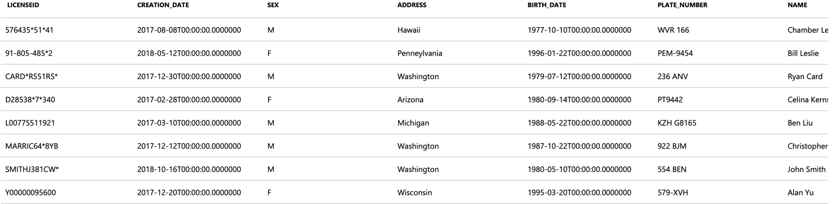

**Step 7.** Currently there are eight records in the database. We are able to use our raspberry Pi or any computer with Python to query them from the local. First, go to this website: <https://docs.microsoft.com/en-us/sql/connect/python/pyodbc/step-1-configure-development-environment-for-pyodbc-python-development?view=sql-server-2017#windows>. You need to install Python first (if you did not install it) and Microsoft ODBC driver for SQL server. This tutorial is specific for windows. Follow the steps from the link, you should see this download page. (next page)

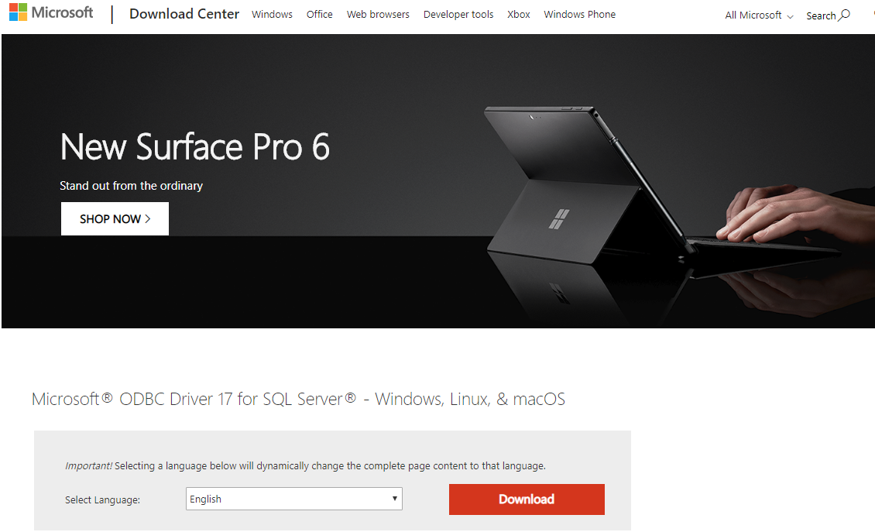

**Step 8.** Click ‘Download’ and follow the steps to install. After install ODBC driver, open a command window and type ‘pip install pyodbc’ to install necessary package. It should finish installing in a few seconds.

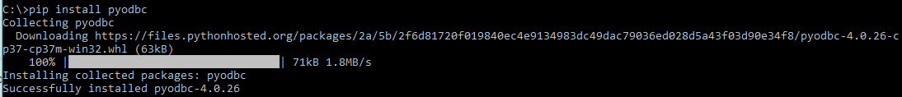

**Step 9.** Download ‘sqlquery.py’ from the folder and use command to direct to your folder where your script is located. Use ‘python “sqlquery.py” to run. You should see the following Error message. Copy paste your IP address from the red block. You need to set a firewall rule for your IP.

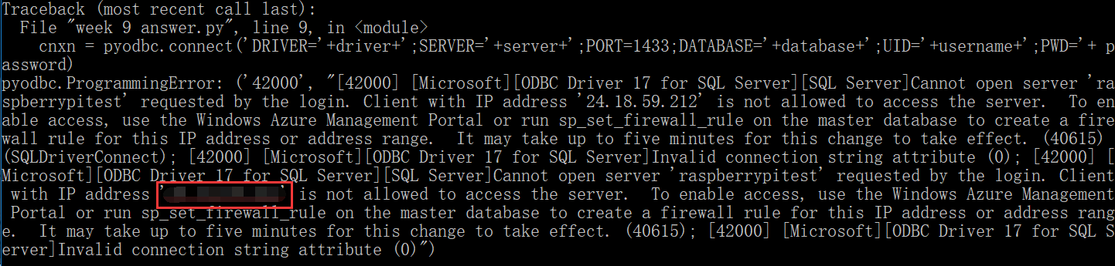

**Step 10.** Back to your web page for the Azure SQL database. If you close the tab, login to the Azure portal again and select the corresponding SQL database. Click ‘Overview’ from the left navigation menu of SQL database, choose ‘set server firewall’. You need to add a rule to the IP address list for the python script to giant access. Click on ‘Save’ to save the rule.

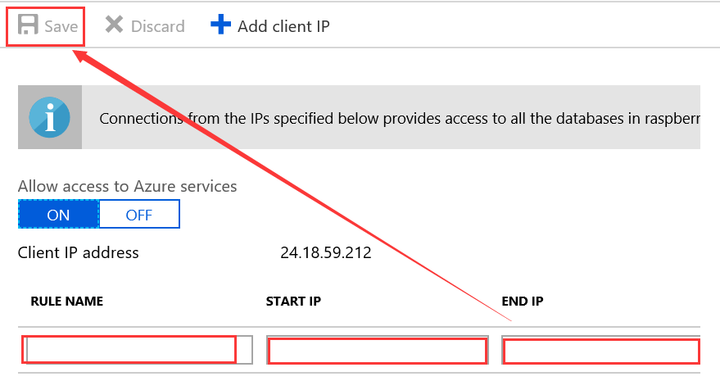

**Step 11.** Now, go back to the command prompt and run the script again. Now it should print out all the information of the database in the console properly.

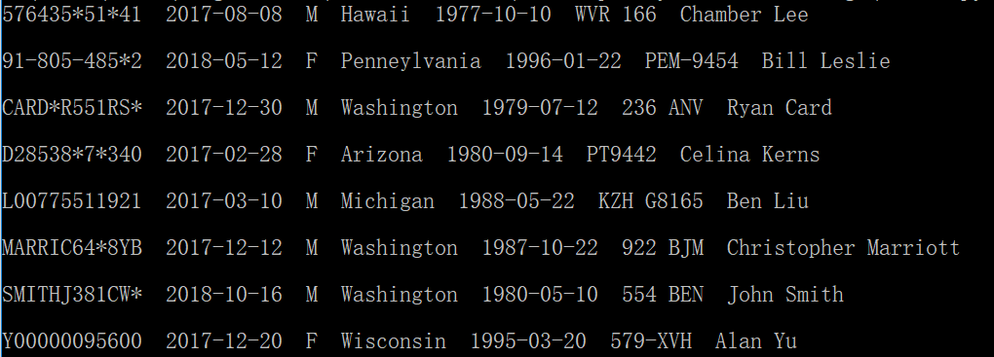

**Step 12.** What we need to do now is to add a few extra lines of code to read the license plate number and modify the SQL command to match our needs. Un-comment line 12 and line 20, comment line 19. Then execute the script again. You should get this following output.



**Step 13.** Study the SQL command on line 20.

**Step 14.** Now we are going to introduce the Azure web app. The official document website is [here](https://azure.microsoft.com/en-us/services/app-service/web/). Websites like wix.com or wordpress.com, they make designing a website so easy and all you need to do is pulling and dragging widgets on their huge number of templates. If you just want to code your website started from scratch, you can learn how to use ASP.NET which is in c#. Since it’s from Microsoft as well, it works a bit nicer than others. Here is a very nice tutorial to build an Azure website using ASP.NET with a SQL database as a back-end. Azure web app service is nothing but a hosting service for your website. We are not going to show case an example here. But there are tons of videos out there that you can learn to build a website.

In the end, I hope you find this course very interesting and intuitive. At least, it gives some basic knowledge of how to combine IoT device and Cloud computing. Here are hot topics and they are getting even more popular in the recent years. If you are good at utilizing vary of cloud services from different platform, using IoT device and sensors, and building database on all kinds of platform. Congratulations! You now can do full-stack development. Although you are just learning concepts and a bit hands-on activities now, you will always get benefits from it soon.

Reference:

1. <https://docs.microsoft.com/en-us/azure/sql-database/sql-database-connect-query-python>
2. <https://social.msdn.microsoft.com/Forums/en-US/31bc774e-22bc-42ca-b0c9-98f0e4311c9c/azure-portal-not-loading-the-loading-screen-displays-forever?forum=windowsazuremanagement>
3. <https://stackoverflow.com/questions/39461850/connecting-to-azure-sql-with-python>
4. <https://docs.microsoft.com/en-us/sql/connect/python/pyodbc/step-1-configure-development-environment-for-pyodbc-python-development?view=sql-server-2017>